**DS 3865**

The CIS Department at Tiny College maintains the Free Access to Current Technology (FACT) library of e-books. FACT is a collection of current technology e-books for use by faculty and students. Agreements with the publishers allow patrons to electronically check out a book, which gives them exclusive access to the book online through the FACT website, but only one patron at a time can have access to a book. A book must have at least one author but can have many. An author must have written at least one book to be included in the system but may have written many. A book may have never been checked out but can be checked out many times by the same patron or different patrons over time. Because all faculty and staff in the department are given accounts at the online library, a patron may have never checked out a book or they may have checked out many books over time. To simplify determining which patron currently has a given book checked out, a redundant relationship between BOOK and PATRON is maintained.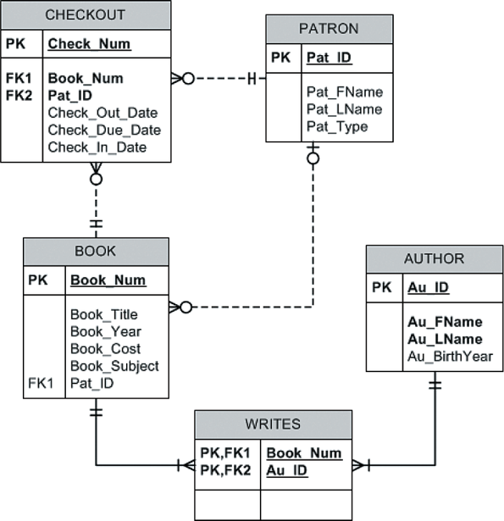

1. Using the Fact\_SQL file posted in iLearn, run the Create statement to create the Checkout, Book, Patron, Writes, and Author tables. – 10 pts
2. Write a query that displays the book title, cost and year of publication for every book in the system. Sort the results by book title. – 10 pts
3. Write a query to display the checkout number, checkout date, and due date for every book that has been checked out sorted by checkout number. A picture of the results is below. – 10 pts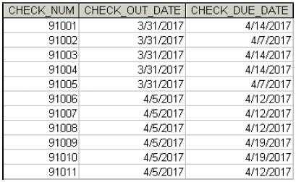
4. Write a query to display the book number, book title, and subject for every book sorted by book number. A picture of the results is below. – 10 pts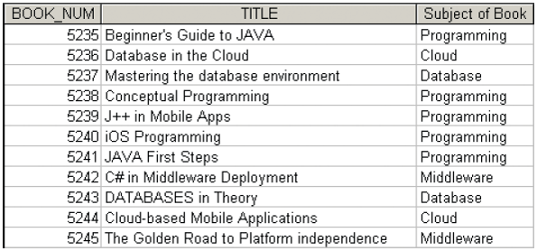
5. Write a query to display the checkout number, book number, and checkout date of all books checked out before April 5, 2017 sorted by checkout number. A picture of the results is below. – 10 pts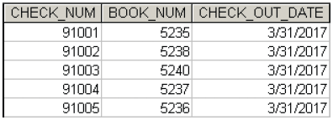
6. Write a query to display the number of books in the FACT system. A picture of the results is below. – 10 pts

C:\Users\sawilliams\Documents\9781337627900_ch07_0291-t2.png

1. Write a query to display the author last name, author first name, and book number for each book written by that author. Sort the results by author last name, first name, and then book number. A picture of the results is below. – 10 pts 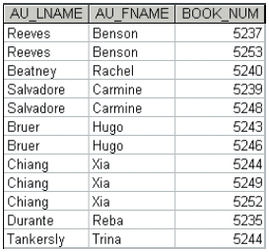
2. Write a query to display the book number, title, author last name, author first name, patron ID, last name, and patron type for all books currently checked out to a patron. Sort the results by book title. A picture of the results is below. – 10 pts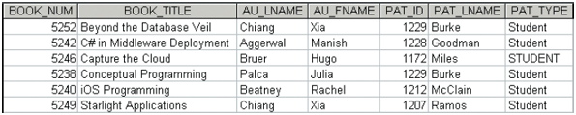
3. Write a query to display the book number, title, and number of times each book has been checked out. Include books that have never been checked out. Sort the results in descending order by the number of times checked out and then by title. A picture of the results is below. – 10 pts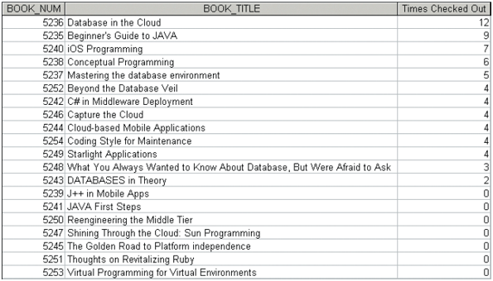
4. Write a query to display the different years in which books have been published. Include each year only once and sort the results by year. A picture of the results is below. – 10 pts

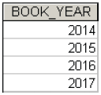

1. Submit your completed queries and results to the dropbox on iLearn.